T.POOJITHA (192412318) ITA0609

Exp-5 : Write a program for Implementation of K-Nearest Neighbours (K-NN) in Python.

Aim

To implement the K-Nearest Neighbours (K-NN) algorithm in Python and classify new data samples using an appropriate dataset.

Algorithm

Import the required libraries.

Load the dataset.

Split the dataset into training and testing sets.

Create the K-NN classifier with a chosen value of K.

Train the classifier using the training data.

Predict the class labels for the test data.

Compare the predicted labels with the actual labels.

Calculate the accuracy of the model.

Display the predicted output and accuracy.

PROGRAM:
# Import required libraries
from sklearn.datasets import load_iris
from sklearn.model_selection import train_test_split from sklearn.neighbors import KNeighborsClassifier from sklearn.metrics import accuracy_score
# Load the Iris dataset iris = load_iris()
X = iris.data # Features
y = iris.target # Target labels
# Split the dataset into training and testing sets X_train, X_test, y_train, y_test = train_test_split(
X, y, test_size=0.2, random_state=42
)
# Create the K-NN classifier (k = 3)
knn = KNeighborsClassifier(n_neighbors=3) # Train the model
knn.fit(X_train, y_train) # Predict the test data
y_pred = knn.predict(X_test) # Calculate accuracy
accuracy = accuracy_score(y_test, y_pred) # Display results
print("Predicted Labels:", y_pred) print("Actual Labels :", y_test)
print("Accuracy:", accuracy * 100, "%")

Input
Dataset: Iris Dataset (loaded using load_iris())

Features:
Sepal Length
Sepal Width
Petal Length
Petal Width

Total Samples: 150
Training Samples: 120
Testing Samples: 30

K = 3

OUTPUT
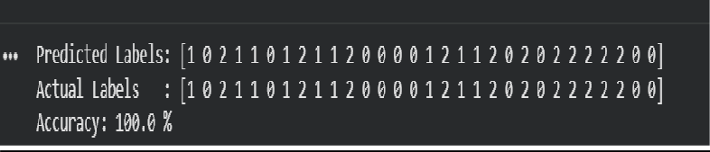

Result
Thus, the K-Nearest Neighbours (K-NN) algorithm was successfully implemented in Python, and the Iris dataset was classified with an accuracy of 100.0%.

